___________________________________

Benchmark Results – November 1999

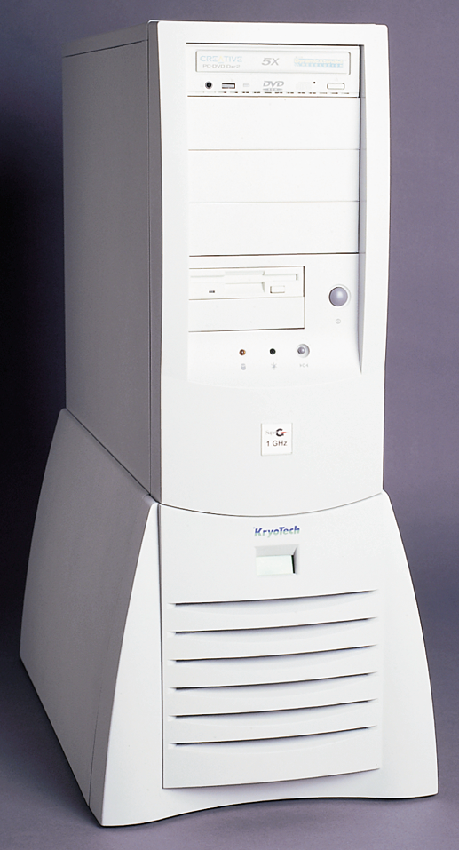



Acknowledgements

KryoTech and Cool Computing and Super G are registered trademarks and the KryoTech logo is a trademark of KryoTech, Inc.
AMD, the AMD logo, AMD Athlon, and combinations thereof and 3DNow! are trademarks of Advanced Micro Devices, Inc.
Winstone and WinBench are registered trademarks and 3D WinBench, WinMark and CPUMark are trademarks of Ziff-Davis Inc. in the United States and other countries.
Microsoft, MS, Windows NT, Windows, PowerPoint, DirectX and Direct3D are registered trademarks of Microsoft Corporation.
Intel and Pentium are registered trademarks and MMX is a trademark of Intel Corporation.
Dell and Dimension are registered trademarks of Dell Computer Corporation.
Corel and WordPerfect are registered trademarks of Corel Corporation. Quattro Pro is a registered trademark of Corel Corporation Limited.
Lotus SmartSuite and 1-2-3 are registered trademarks and WordPro is a trademark of Lotus Development Corporation.
Netscape and Netscape Navigator are registered trademarks of Netscape Communications Corporation in the United States and other countries.
SolidWorks is a registered trademark of SolidWorks Corporation.
SPECapc is a service mark of Standard Performance Evaluation Corporation.
Other product names used in this publication are for identification purposes only and maybe trademarks of their respective companies.

Notice
KryoTech, Inc. reserves the right to make improvements or changes to this document and the Products described at any time, without notice or obligation.
The information in this document has been reviewed and is believed to be accurate. However, KryoTech, Inc. does not assume any responsibility for inaccuracies, errors, or omissions that may be contained herein. In no event will KryoTech, Inc. be liable for direct, indirect, special, incidental, or consequential damages resulting from any defect or omission in this document, even if advised of the possibility of such damages.
No part of this document may be photocopied, reproduced, or translated to another language without prior written authorization from KryoTech, Inc.
Document: ATH-E11-BMK, November 1999.
Copyright © 1999 by KryoTech, Inc. All rights reserved.

Table of Contents
Introduction 4
System Benchmarks 6
Ziff-Davis WinBench® 99 v1.1 6
CPUMark 99 6
FPU WinMark 99 7
Graphics WinMark 99 8
WinTune98 8
Ziff-Davis 3D WinBench™ 99 v1.2 (Transform & Lighting) 9
Application Benchmarks 10
Business Applications 10
Ziff-Davis Winstone 99 v1.1 10
Entertainment Software 11
Quake II and III 11
3D CAD Software 12
SPECapcSM SolidWorks® 98Plus 1.0 12
Appendix 13
KryoTech Cool Athlon 800 Configuration Information 13

Introduction
This document provides the results of performance benchmarks measured by KryoTech as part of qualifying the Super G™ as a commercial product. Results are provided for generic system level metrics as well as some business and entertainment applications.

The Super G combines two leading edge technologies—the AMD Athlon processor and KryoTech's -40° cooling system—to create the world's fastest PC.

The AMD Athlon processor is an x86-compatible, seventh-generation design featuring:
- A super-pipelined, nine-issue superscalar microarchitecture optimized for high clock frequency
- The industry's first fully pipelined, superscalar floating point unit for x86 platforms
- High-performance cache technology, including 128KB of on-chip level one (L1) cache and a programmable, high performance backside level two L2 cache interface
- Enhanced 3DNow!™ technology and multimedia performance
- A 200 MHz system interface bus based on the Alpha™ EV6 bus protocol.
KryoTech, the leader in Cool Computing®, integrates its active cooling technology with computer systems to increase their speed and performance. It is a well-understood characteristic of CMOS devices that their switching speeds can be significantly and safely increased at lower temperatures. KryoTech's -40°C cooling system encapsulates and thermally insulates the processor and lowers its operating temperature so it can be thermally accelerated to run faster and more reliably.

KryoTech sells the Super G as a "bare-bones" system consisting of:
- AMD Athlon processor thermally accelerated to 1000 MHz
- ATX motherboard
- KryoTech -40°C cooling system
- ATX computer case with 300 watt power supply

To complete the system, the user must add their own computer components—typically system memory, hard disks, floppy drive, CD-ROM or DVD drive, graphics accelerator card, sound card, modem, monitor, keyboard, and mouse.
KryoTech uses benchmarks that measure the performance of the components of the bare-bones configuration it sells. Specifically, the integer and floating point performance of the thermally accelerated processor, its performance as a part of the PC's graphics, as well as its performance for compute intensive applications. Since the user chooses and installs many of the other system components, no attempt is made to characterize these devices or their many combinations.

This document will be updated as KryoTech measures other benchmarks. The latest benchmark results can be found on KryoTech's website at www.kryotech.com. In addition, links to other published results can also be found there.

System Benchmarks

Ziff-Davis WinBench® 99 v1.1

The WinBench® 99 benchmarks measure the performance of a PC's individual subsystems—processor, graphics, and disk—based on the Ziff-Davis Winstone® 99 test suites (see next section). Comparative results are presented for the processor benchmarks—CPUMark™ 99 and FPU WinMark™ 99. The results of the Graphics WinMark 99 and WinTune 98 tests are provided for informational purposes.

CPUMark 99

The CPUMark 99 benchmark measures the performance of a system’s processor and memory sub-systems. The performance of a processor is measured without the impact of other sub-systems, such as the graphics and disk sub-systems.1

FPU WinMark 99

Similarly, the FPU WinMark 99 benchmark tests the floating point performance of the processor using the same Winstone 99 test suites.1

Graphics WinMark 99

The Graphics WinMark benchmark runs a series of practically nonstop graphics stress tests that intersperse graphics, disk, and processor work. Two scores are produced—Business Graphics and High-End Graphics—using the results of the Winstone 99 test suites. The scores are normalized relative to the same reference system used for reporting Winstone 99 results (233 MHz Dell® Dimension® PC).

Benchmark | WinMark 99 Score on WinBench 99 v 1.1 for Windows 98
Business Graphics WinMark 99 | 377.0
High-End Graphics WinMark 99 | 1150.0

See also 3D WinBench99 on the next page.

WinTune98

The Dhrystone MIPS benchmark is widely used in the computer industry as a measure of performance. WinTune98 uses a modified version of the Dhrystone that keeps its data on the program stack. The Dhrystone benchmark performs the sort of complicated sequences of instructions that real applications use. The Dhrystone result is determined by measuring the time it takes to perform these sequences of instructions.

The Whetstone MFLOPS benchmark is widely used in the computer industry as a measure of performance. The Whetstone measures floating-point arithmetic performance. Floating-point arithmetic is most significant in scientific, engineering, statistical and computer-aided design (CAD) programs. It is also a small component in spreadsheet, paint and drawing programs.

Benchmark | WinTune98 for Windows 98
CPU Integer MIPS | 3035
CPU Floating Point MFLOPS | 1250

Ziff-Davis 3D WinBench™ 99 v1.2 (Transform & Lighting)

In addition to WinBench 99, Ziff-Davis also provides a specialized 3D benchmark—the 3D WinBench 99.

The 3D WinBench™ 99 test suite measures the performance of a PC's 3D subsystem, which includes the Direct3D® software, the monitor, the graphics adapter, the graphics driver, and the bus used to carry information from the graphics adapter to and from the processor subsystem. Because it more directly reflects a processor's 3D capabilities, only the results of the 3D WinBench 99 Transform and Lighting tests are reported. 1

Application Benchmarks

Business Applications

Ziff-Davis Winstone 99 v1.1
The Winstone 99 benchmark is a system-level, application-based test that measures a PC's overall performance when running today's most popular suites of business applications—Corel® WordPerfect® Suite 8 (Quattro® Pro 8, WordPerfect 8); Lotus SmartSuite® (1-2-3® 97, Word Pro™ 97); Netscape Navigator® 4.04; and Microsoft® Office 97 (Access 97, Excel 97, PowerPoint® 97, Word 97).

Using actual application code, the suites are run through a series of scripted activities. Multiple applications are kept open as Winstone 99 switches between the applications and Netscape Navigator. Within each of its three office-suite tests, Winstone 99 measures how long a PC takes to complete each script. It then converts each timing to a score relative to the time a reference machine took to complete the same script. A Dell Dimension PC with a 233-MHz Pentium® MMX™ processor, 32MB of SDRAM, and a 1024-by-768 graphics resolution using 24-bit color is used as the reference machine with a defined score of 10.0 Winstone 99 units.1

Entertainment Software

Quake II and III

id Software's Quake is one of today's leading titles in entertainment software. Known for its graphical realism, it is a computationally intensive application that stresses a system's CPU, especially the floating point unit. KryoTech's benchmark results for Quake are provided here for informational purposes.

 | Frames per Second (FPS)/Resolution
Benchmark | 640x480 | 800x600 | 1024x768
Quake II - demo1 | 159.4 | 99.5 | 63.4
Quake II - massive1 | 138.9 | 92.8 | 61.7
Quake II - crusher | 108 | 71.2 | 51.6
Quake III - q3demo1 | 117.5 | 98.8 | 64.0
Quake III - q3demo2 | 118.9 | 109.4 | 77.7

3D CAD Software

SPECapcSM SolidWorks® 98Plus 1.0
SPECapc's SolidWorks 98Plus™ Benchmark is a program that was written in Visual Basic and C that runs on the Windows NT and Windows 95 OS platforms. It was developed by SolidWorks and later enhanced by SPEC/GPC's Application Performance Characterization (SPECapcSM) project group. The SolidWorks 98Plus Benchmark provides an application benchmark for the mechanical design user (CAD/CAM).
The benchmark loads some standard models into SolidWorks 98Plus. The models are of small to large-medium size (the largest of which is a line assembly model with 276,000 polygons). The benchmark then does I/O, CPU, and graphics timings on operations to these models. The scores are a geometric mean of the time in seconds to do all the tests and then normalized to a reference machine (300-MHz Pentium II processor; PERMEDIA 2 graphics processor) chosen by the SPECapc group's membership.
The following results were measured by CADdesk magazine in the United Kingdom and KryoTech Labs in the United States.
Additional information about SolidWorks, the SolidWorks 98Plus Benchmark, and CADdesk Magazine can be found on the internet at:

SolidWorks – www.solidworks.com

SolidWorks 98Plus Benchmark – http://www.specbench.org/gpc/apc.static/solid.htm

CADdesk Magazine – http://www.edaltd.co.uk/contact.htm

Appendix

KryoTech Super G Configuration Information

Hardware
Processor | AMD Athlon processor thermally accelerated to 1000MHz
Motherboard | Microstar 6167 rev. 1 with AMD-750™ chipset (Note 2)
BIOS | WMS667 MicroStar 1.3
Memory | Single 128 MB PC-100 DIMM
Cache | 125KB L1 on processor; 512K L2 SRAM on processor module (1/3 speed)  KryoTech is researching increased cache speed settings.
Hard Disk | Western Digital® Corporation, Western Digital Expert™ WD41800, 18MB, EIDE hard drive using FAT32 file system and Ultra ADA/66 with an integrated HDC. No hardware cache.
Graphics | Diamond Multimedia Systems, Inc., Diamond Viper770 Ultra based on the nVidia TNT2 Ultra with 150 MHz core, 183MHz memory clock, and 32MB Video memory
Other | Iomega ZIP Drive; Toshiba 6x DVD ROM drive SD-M1202

Software
Operating System | Microsoft® Windows® 98 Second Edition 4.10.2222A
AGP Driver | AMD AGP miniport driver v4.45
Graphics Driver | nVidia Riva TNT2 Ultra driver v4.11.01.0208
DirectX | DirectX version 6.1A
Monitor Resolution | 1024 x 768 pixels with 16bit color and a refresh rate of 100Hz
IDE Driver | AMD Bus Mastering EIDE driver v1.11

Notes:

- All tests were performed without independent verification by Ziff-Davis. Ziff-Davis makes no representations or warranties as to the results of the tests.

- The Super G may include either a Gigabyte GA-7IX or a MicroStar MS-6167 motherboard as determined solely by KryoTech during manufacturing. Shipments planned to begin in December 1999.

KryoTech, Inc.

724 Chris Drive, Suite 110

West Columbia, SC 29169

Telephone: +1 (803) 926-0066

Fax: +1 (803) 926-0807

http://www.kryotech.com/

1 Source for PIII benchmark results is the AMD website at http://www.amd.com/products/cpg/athlon/benchmarks/winbenchcpu.html.
1 Source for PIII benchmark results is the AMD website at http://www.amd.com/products/cpg/athlon/benchmarks/winbenchfpu.html
1 Source for PIII benchmark results is the AMD website at http://www.amd.com/products/cpg/athlon/benchmarks/3dwinbenchtrans.html
1 Source for PIII benchmark results is the AMD website at http://www.amd.com/products/cpg/athlon/benchmarks/winstone9998.html

